Hay Town Council

Clerk: Mr Nicholas Burdekin
Hay Town Council
Council Offices
Brecon Road
Hay-on-Wye
HR3 5DY

01497 820296
townclerk@haytowncouncil.gov.uk
www.haytowncouncil.gov.uk

-
#
#####
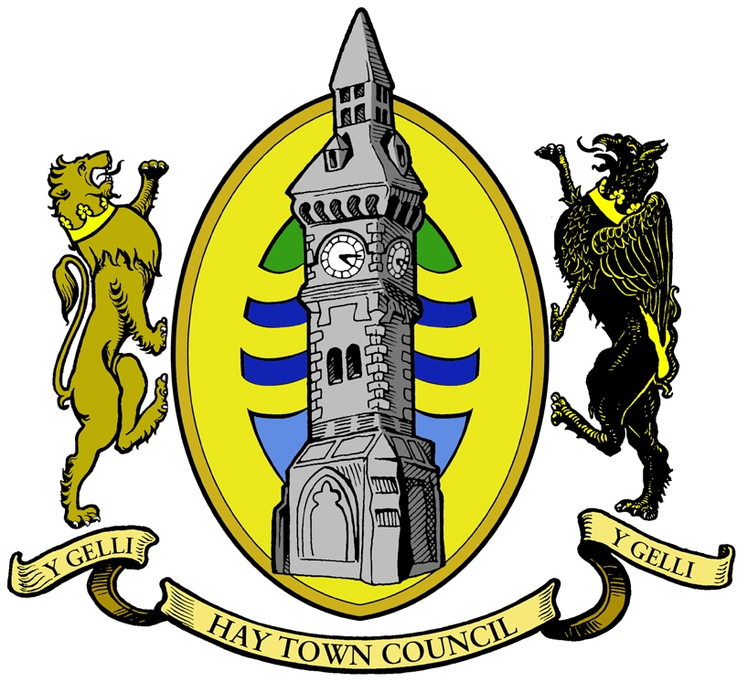

Mayor – Cllr S Morris

The next meeting of Hay Town Council will take place in the Sports Pavilion, Brecon Road, Hay-on-Wye on Monday 7th June 2021 at 6.30pm

Please note, under the new Local Government and Elections (Wales) Act 2021, Councils are required to provide access to remote meetings for members of the public and the press. If you would like to access the meeting remotely, please see details at the bottom of the agenda on how to join via the Zoom platform

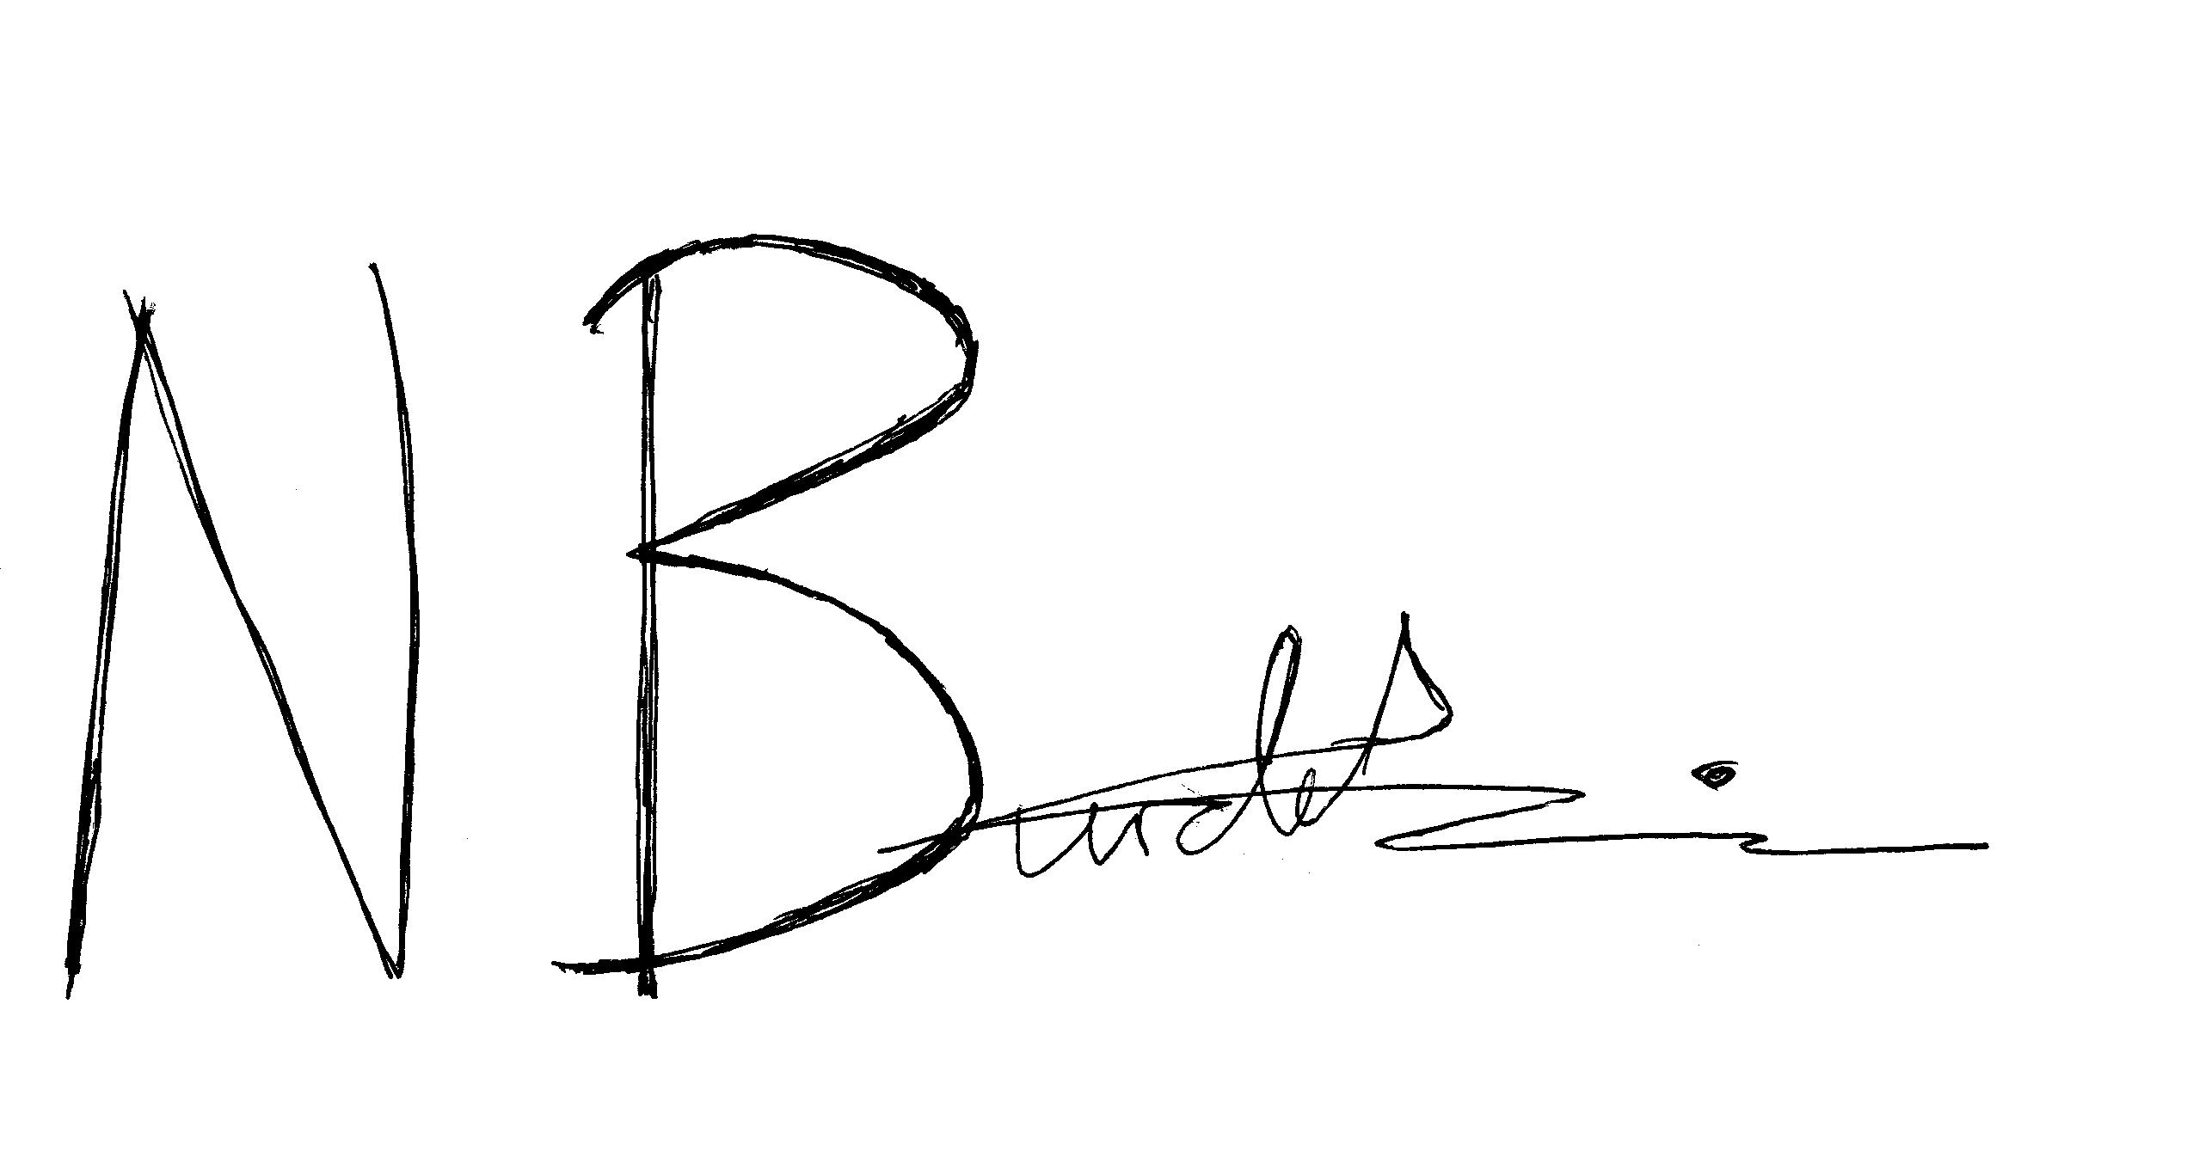

Nick Burdekin

Clerk to the Council

AGENDA
Target Time

- Apologies for absence

- Declarations of Interest & Code of Conduct

- Questions from Members of the Public

- Minutes of the meeting dated 17th May 2021

- Matters arising from minutes not listed on the agenda: (a) 20 mph zone for Hay – update from Cllr GR; (b) ‘Paw Prints’ campaign – launch 7th June weather-dependent; (c) Any other items

- Transforming Towns
(i) Outstanding items for grant claim to be made

- Implementation of Social Distancing Measures in Hay
- Review of current measures
(ii) Any further issues

- Hay Post Office Closure – update from JBG/DL/‘Access to Cash’

- Sub Committee Reports/Minutes: 7.00 pm
(a) Estates and Premises
(i) Minutes of meeting dated 3rd June 2021

- Finance
- Special Council meeting to be agreed to consider Annual Return 2020/2021

- Communications
(i) Minutes of meeting dated 20th May 2021

- Events
(i) Minutes of the meeting dated 27th May 2021

- Sports Clubs

- Councillor Protocols

- Cattle Market Project

- Hay Cemetery
- Update on purchase of land

- Consultations - none

- Play Areas monthly inspections
- Monthly inspections

- Report of the Clerk/Responsible Financial Officer 7.45 pm
- Correspondence
(a) Red Cross Renovations
(b) LATE CORRESPONDENCE

(ii) Bank Balances

(iii) Bank Reconciliations

- Report from County Councillor

- Report from Chairman 8.00 pm

- Reports from representatives: (a) Dyfed Powys Police; (b) Gwynne’s Almshouses; (c) Dial-a-Ride; (d) Hay School Governors; (e) One Voice Wales; (f) Bronllys Wellbeing Trust; (g) Cheesemarket; (h) Hay to Timbuktu (H2T); (i) BBNP; (j) Chamber of Commerce; (k) Hay Summer Show; (l) HADSCAL community centre (deferred); (m) Hay Markets; (n) Hay Castle Trust; (o) Hay Sports Clubs

- Planning
(a) Urgent Mayor and Deputy Mayor Authorisation - none

- Planning Applications for Comment
(i) Application Reference: 21/20008/TRCA – 2 Mill Bank, Hay-on-
Wye HR3 5DH – Row of conifer trees/over-grown boundary
conifer hedge. Fell to ground level

- Any Other Business – for information purposes only 8.30 pm

- Date and time of next meeting - Monday 5th July 2021, 6.30 pm

General Data Protection Regulations (GDPR) 2018

If you would like to attend the meeting virtually, please contact Hay Town Clerk at least one working day prior to the meeting on: townclerk@haytowncouncil.gov.uk or by calling 07714 224 554.

Please note, any e-mail addresses given by the press or members of the public for the purposes of joining the meeting remotely will be deleted from all Hay Town Council’s records directly after the meeting has occurred in order to fulfil Hay Town Council’s duty under the GDPR Regulations (2018).

